**Nasze pupile**

|  |  |  |
| --- | --- | --- |
| Zwierzę | Liczba | Procent |
| kot | 17 | 14% |
| chomik | 14 | 12% |
| kanarek | 10 | 8% |
| świnka morska | 4 | 3% |
| papuga | 4 | 3% |
| żółw | 4 | 3% |
| rybki | 5 | 4% |
| królik | 10 | 8% |
| wąż | 3 | 2,5% |
| pies | 40 | 33% |
| nie wiem | 14 | 12% |

Ankietowanych było 120 osób.

Najwięcej głosów otrzymał pies a najmniej wąż.

[](https://www.bing.com/images/search?view=detailV2&ccid=9698L9uC&id=F31B6B72A9A99E41BB3EC07745458FC12A6C7009&thid=OIP.9698L9uCo9iRUviYpYtNiAHaFX&mediaurl=http://2.bp.blogspot.com/-pZEJmC3kVd8/T8sklKdAQrI/AAAAAAAAACk/uNxCHup4Iik/s1600/Kr%C3%B3lik4.jpg&exph=290&expw=400&q=zwierzenta+domowe&simid=608019955693519030&selectedIndex=165)

[](https://www.bing.com/images/search?view=detailV2&ccid=amsf95tG&id=F8BCE2D75B4CF3619BE93DD74182B39CA38370C9&thid=OIP.amsf95tG69-REyP7YTbCVQHaFX&mediaurl=http://www.petmd.com/sites/default/files/diarrhea-guinea-pigs.jpg&exph=428&expw=590&q=zwierzaki+domowe&simid=608050849418054951&selectedIndex=115)[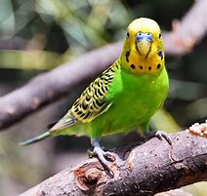](https://www.bing.com/images/search?view=detailV2&ccid=l0bTdZBE&id=36E93CDC51DFA89C505C94040E6BBB5AAC479255&thid=OIP.l0bTdZBEOtzSJEGt5s1kHQHaHa&mediaurl=http://2.bp.blogspot.com/-smDzVjt5MN4/Uwn7x57TteI/AAAAAAAAABY/nQdIjTa72WQ/s1600/papuzka-falista-jasnozielona.jpg&exph=600&expw=600&q=papuga++domowa&simid=608000508100871321&selectedIndex=12&cbir=sbi)[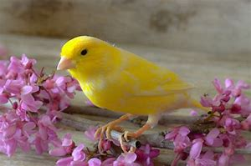](https://www.bing.com/images/search?view=detailV2&ccid=DafF8KhD&id=2A79A5FDDDC8EC19B9A6CE5AE5F84A0F5B61E98B&thid=OIP.DafF8KhD7FVs4TZogAJ5kwHaE6&mediaurl=http://www.zoo-mar.pl/wp-content/uploads/2015/06/zakup-kanarka.jpg&exph=531&expw=800&q=kanarek&simid=608001216766410768&selectedIndex=4)[](https://www.bing.com/images/search?view=detailV2&ccid=elzv5ps1&id=B75690CBD8611C2748EA4911B776D74D326754E0&thid=OIP.elzv5ps1rbZmm9G50q94zAHaIA&mediaurl=https://mamazoneCDN.azureedge.net/cache/Single-136978-noworodek-i-zwierze.jpg&exph=1120&expw=1035&q=zwierzaki+domowe&simid=608030985187034664&selectedIndex=4)

[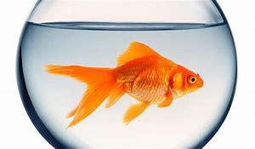](https://www.bing.com/images/search?view=detailV2&ccid=ri8Yg4B5&id=4DA302D90D6FF8CB3B3EBBC206B40CB25FFAAFCB&thid=OIP.ri8Yg4B5-cOq3uA6QSarBAHaEV&mediaurl=https://www.krakvet.pl/artykuly/wp-content/uploads/2016/04/Blog_KV_Co_potrafi_pies_800x6001-752x440.jpg&exph=440&expw=752&q=rybki+do+akwarium&simid=608048942473218099&selectedIndex=5&cbir=sbi)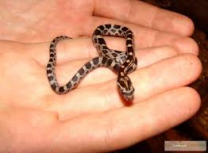[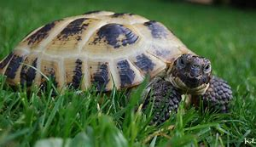](https://www.bing.com/images/search?view=detailV2&ccid=vGADWxF2&id=BDB2997FC1206B27D3F6152BC9B18924E118E624&thid=OIP.vGADWxF24JKirD9a2pQHqQHaES&mediaurl=http://s3.flog.pl/media/foto/2774979_zolw-porusza-sie-z-predkoscia-wystarczajaca-do-upolowania-salaty-----t-pratchett.jpg&exph=741&expw=1280&q=%c3%b3%c5%82w&simid=608053031230833759&selectedIndex=32&cbir=sbi)[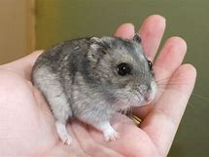](https://www.bing.com/images/search?view=detailV2&ccid=APTjofLh&id=0C34C8AF344B4DF8B6098F3761E0688D8F7A0394&thid=OIP.APTjofLhLCMOAFrj47Er7QHaFi&mediaurl=https://www.pets4homes.co.uk/images/classifieds/2014/03/22/586087/large/plum-pudding-cheeky-dwarf-hamster-needs-a-home-532d8a7c13526.jpg&exph=958&expw=1280&q=zwierzaki+domowe&simid=608051051292200284&selectedIndex=143)

Opracowała: Julia Sz. i zespół koła dziennikarskiego